Resources

Figures

Figure 1.1 A competence model
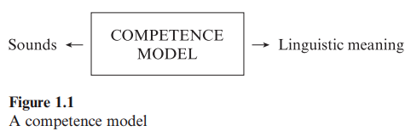

Figure 1.2 A performance model
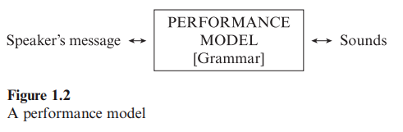

Figure 1.3 An acquisition model
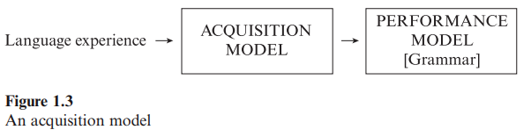

Bibliography
Chomsky, N. 1965. Aspects of the theory of syntax. Cambridge, Mass.: MIT Press.
Chomsky, N. 1972. Language and mind. Enlarged ed. New York: Harcourt Brace Jovanovich.
Chomsky, N. 1975. Reflections on language. New York: Pantheon Books.

